# Capstone Project - The Battle of Neighbourhoods

## London New Business Analysis

## March 2020

## Problem Statement:

Where is best area of Greater London to open a new business (either a pub or a coffee shop) in London in 2020.

## Description of the problem and background

Greater London is a large and diverse area in the UK. It is made up of 32 boroughs and covers over 600 square miles[1]. Each borough has its own characteristics from busy areas of central London to the relatively quieter residential districts.

Anyone setting up a new business in “London” has a difficult decision to make when choosing a location, so I am seeking to demonstrate how Data Science can help with that decision in terms of analysing characteristics of each borough and using the Foursquare API to cluster different businesses in each borough.

## Data Sources

The majority of the data on London Boroughs will be taken from publicly available dataset on Wikipedia (<https://en.wikipedia.org/wiki/List_of_London_boroughs>). This data will require a level of manual cleaning to ensure it is fit for analysis.

The Foursquare API (<https://developer.foursquare.com>) will be used to retrieve information about existing businesses in these Boroughs.

Levels of Weekly pay by London borough are sourced from Office for National Statistics. (<http://www.statistics.gov.uk/statBase/product.asp?vlnk=13101>)

Using the data I will seek to examine population density, earning levels and similar businesses for each Borough and try to estimate where a new business (pub or coffee shop) is likely to have the best chance of succeeding in Greater London.

## Potential limitations

Anecdotally Foursquare is considered less popular in the UK than perhaps North America – so the accuracy of the business data may limit the success of this analysis.

In addition, each Borough in London covers a wide area (compared to previous case studies used in the course so far). To illustrate this the largest Borough, Bromley, covers also 60 square miles. To mitigate for this I will seek to use a wide radius (5000 metres) in the Foursquare API to cover a wide area.

Without paying for other data sources, there is only limited data on London Boroughs available in the public domain. If this was a professional analysis – further analysis could be considered by paying for additional datasets. There is also a risk that data from Wikipedia could be wrong or could change during the model exercise!

## Methodology

1. Import London Boroughs and London Earnings datasets into Panda dataframe
2. Examine Population and Population Density for each Borough using visualisation
3. Examine Earnings in each Borough using visualisation
4. Use Foursquare API to examine businesses located in each Borough.
5. Cluster business data using K-means clustering
6. Plot clusters on map and examine results
7. Attempt to find a borough with highest population density, high hourly wage and a low clustering of coffee shops or pubs.

For more details refer to Notebook section.

## Results

The visualisations below were produced in the analysis

1. London Borough by Population Density

1. London Borough by Hourly Wage

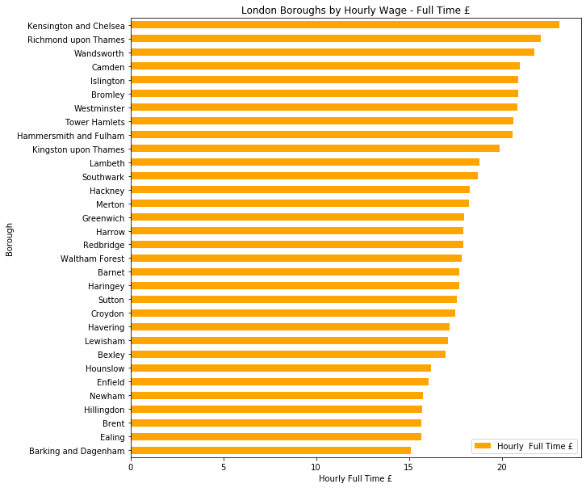

1. Clustering Map

## Clusters Results Set

|  |  |  |  |  |  |  |  |  |  |  |  |
| --- | --- | --- | --- | --- | --- | --- | --- | --- | --- | --- | --- |
| Borough | Cluster Labels | 1st Most Common Venue | 2nd Most Common Venue | 3rd Most Common Venue | 4th Most Common Venue | 5th Most Common Venue | 6th Most Common Venue | 7th Most Common Venue | 8th Most Common Venue | 9th Most Common Venue | 10th Most Common Venue |
| Camden | 0 | Hotel | Bookstore | Steakhouse | Pizza Place | Theater | Cocktail Bar | Coffee Shop | Art Gallery | Indian Restaurant | Ice Cream Shop |
| Islington | 0 | Hotel | Cocktail Bar | Coffee Shop | Pub | Pizza Place | Market | Steakhouse | Sushi Restaurant | Flea Market | Bakery |
| Kensington and Chelsea | 0 | Hotel | Café | Garden | Juice Bar | Park | Art Gallery | Japanese Restaurant | Indian Restaurant | Department Store | Hotel Bar |
| Southwark | 0 | Hotel | Theater | Cocktail Bar | Coffee Shop | Scenic Lookout | Street Food Gathering | Sushi Restaurant | Garden | Pub | Pizza Place |
| Westminster | 0 | Hotel | Cocktail Bar | Lounge | Art Gallery | Bookstore | Steakhouse | Theater | Park | Art Museum | Plaza |
| Ealing | 1 | Pub | Coffee Shop | Park | Café | Hotel | Botanical Garden | Middle Eastern Restaurant | Pizza Place | Bakery | Sushi Restaurant |
| Hounslow | 1 | Pub | Park | Coffee Shop | Indian Restaurant | Portuguese Restaurant | Supermarket | Café | Rugby Stadium | Hotel | Gym |
| Kingston upon Thames | 1 | Pub | Café | Park | Coffee Shop | Garden | Supermarket | Burger Joint | Gastropub | German Restaurant | Gift Shop |
| Lewisham | 1 | Pub | Park | Coffee Shop | Café | Indian Restaurant | Beer Store | Bar | Italian Restaurant | Garden Center | Fish & Chips Shop |
| Merton | 1 | Pub | Park | Coffee Shop | Café | Bar | Sushi Restaurant | Italian Restaurant | Tennis Stadium | Supermarket | Burger Joint |
| Richmond Thames upon | 1 | Pub | Park | Garden | Coffee Shop | Café | Italian Restaurant | Rugby Stadium | Hotel | Bakery | Scenic Lookout |
| Tower Hamlets | 1 | Pub | Park | Coffee Shop | Café | Bar | Garden | History Museum | Farm | Turkish Restaurant | Beer Bar |
| Waltham Forest | 1 | Pub | Coffee Shop | Park | Pizza Place | Café | Brewery | Nature Preserve | Italian Restaurant | Restaurant | Gym / Fitness Center |
| Barnet | 2 | Café | Coffee Shop | Park | Turkish Restaurant | Supermarket | Mediterranean Restaurant | Greek Restaurant | Bakery | Gym / Fitness Center | Pub |
| Enfield | 2 | Pub | Coffee Shop | Turkish Restaurant | Gym / Fitness Center | Park | Café | Garden Center | Supermarket | Grocery Store | Greek Restaurant |
| Hackney | 2 | Pub | Coffee Shop | Café | Bakery | Cocktail Bar | Park | Pizza Place | Bookstore | Beer Bar | Brewery |
| Hammersmith and Fulham | 2 | Café | Coffee Shop | Pub | Gym / Fitness Center | Pizza Place | Gastropub | Park | Fish & Chips Shop | Bakery | Indian Restaurant |
| Haringey | 2 | Turkish Restaurant | Coffee Shop | Café | Pub | Park | Mediterranean Restaurant | Bakery | Trail | Pizza Place | Organic Grocery |
| Lambeth | 2 | Park | Coffee Shop | Café | Pizza Place | Italian Restaurant | Theater | Market | Beer Store | Bar | Pub |
| Wandsworth | 2 | Park | Coffee Shop | Café | Pub | Pizza Place | French Restaurant | Tennis Stadium | Soccer Stadium | Bakery | Yoga Studio |
| Barking and Dagenham | 3 | Supermarket | Grocery Store | Coffee Shop | Park | Pub | Italian Restaurant | Café | Fast Food Restaurant | Bakery | Gym / Fitness Center |
| Bexley | 3 | Pub | Grocery Store | Supermarket | Coffee Shop | Italian Restaurant | Clothing Store | Furniture / Home Store | Pharmacy | Park | Fast Food Restaurant |
| Bromley | 3 | Coffee Shop | Pub | Park | Grocery Store | Pizza Place | Indian Restaurant | Gym / Fitness Center | Café | Mediterranean Restaurant | Gastropub |
| Croydon | 3 | Pub | Park | Grocery Store | Coffee Shop | Supermarket | Pizza Place | Mediterranean Restaurant | Clothing Store | Hotel | Gym / Fitness Center |
| Greenwich | 3 | Pub | Park | Coffee Shop | Hotel | Gym / Fitness Center | Historic Site | Grocery Store | Clothing Store | Garden | Asian Restaurant |
| Havering | 3 | Coffee Shop | Grocery Store | Supermarket | Pub | Café | Italian Restaurant | Park | Fast Food Restaurant | Bakery | Clothing Store |
| Hillingdon | 3 | Pub | Coffee Shop | Grocery Store | Pharmacy | Pizza Place | Indian Restaurant | Supermarket | Sandwich Place | Hotel | Gym / Fitness Center |
| Newham | 3 | Pub | Hotel | Park | Coffee Shop | Gym / Fitness Center | Café | Turkish Restaurant | Historic Site | Plaza | Burger Joint |
| Redbridge | 3 | Park | Pub | Grocery Store | Supermarket | Café | Indian Restaurant | Pizza Place | Train Station | Gym | Coffee Shop |
| Sutton | 3 | Park | Coffee Shop | Pub | Grocery Store | Supermarket | Café | Italian Restaurant | Pizza Place | Clothing Store | Hotel |
| Brent | 4 | Indian Restaurant | Pub | Supermarket | Coffee Shop | Middle Eastern Restaurant | Park | Gym / Fitness Center | Café | Portuguese Restaurant | Pizza Place |
| Harrow | 4 | Indian Restaurant | Coffee Shop | Park | Pub | Café | Gym / Fitness Center | Portuguese Restaurant | Italian Restaurant | Supermarket | Middle Eastern Restaurant |

## Conclusions

The analysis shows that the both Cluster 0 and Cluster 4 has the lowest number of pubs and coffee shops of all the London Boroughs.

## Limitations of the Analysis

Foursquare is considered less popular in the UK than perhaps North America – so the accuracy of the business data may limit the success of this analysis.

Borough in London covers a wide area (compared to previous case studies used in the course so far) and a standard radius (5000 metres) does not cover or limit the analysis sufficiently.

Wage data was taken from 2019 and takes not account of earnings of visitors or employees who visit the areas each day.

No consideration of rents in the area which has a big impact on success of new business

Analysis of businesses using Foursquare API only considers ranking of businesses in borough and not the number of coffee shops. Just because coffee shops are 3rd most common venue if Foursquare doesn’t mean there is shortage of coffee shops in the Borough.

1. Source: https://en.wikipedia.org/wiki/Greater_London